Tentorial dural AV fistula
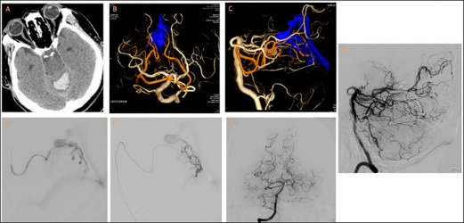
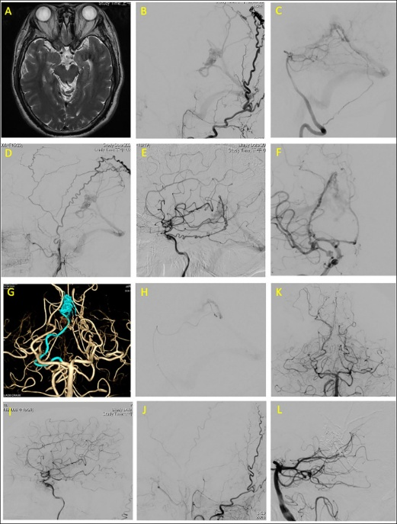
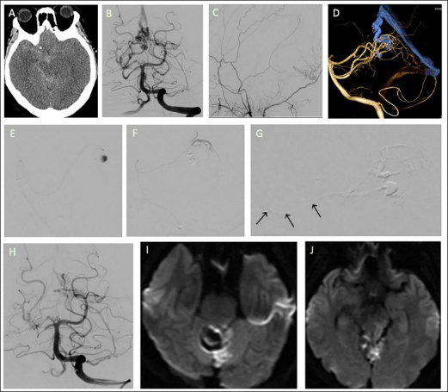

Functional recovery 2020
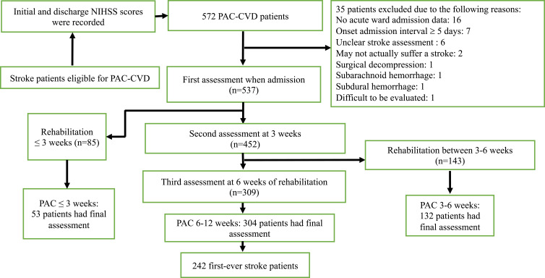

Recovery of walking ability PAC 2023
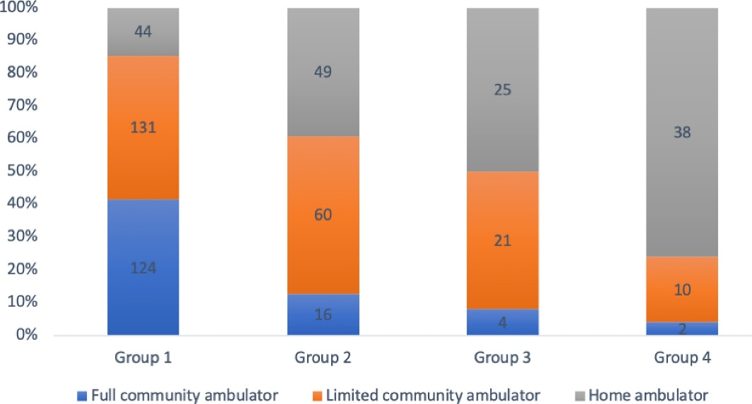

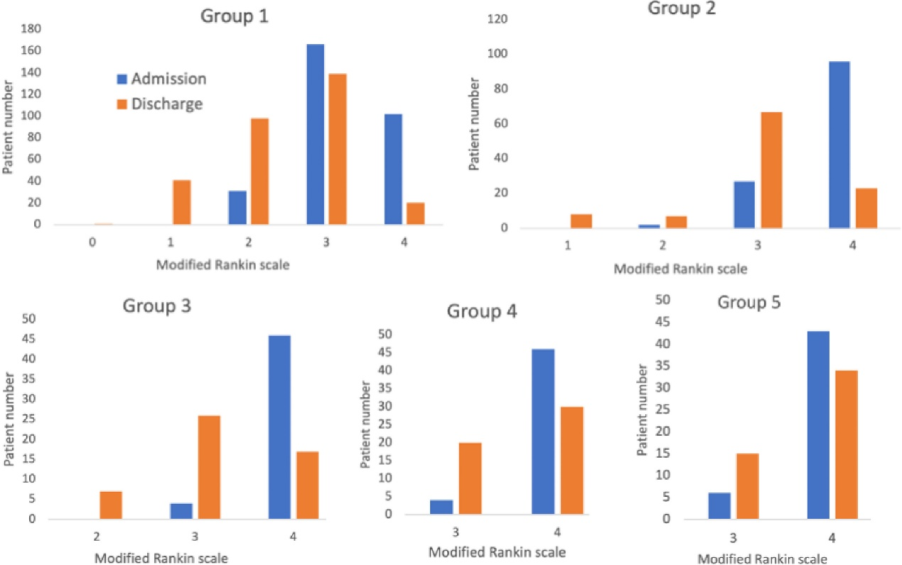
Table 3. Results of Stepwise Linear Regression Analysis of Factors Predicting Gait Speed at PAC discharge.
Predictor | Unstandardized Coefficient | Coefficients standard error | Adjusted R Squareª | Standardized coefficient | 95% CI (lower and upper bound) |  | p value
Constant | 0.8 | 0.131 |  |  | 0.543 | 1.058 | <0.001∗∗∗
BBS | 0.011 | 0.001 | 0.371 | 0.505 | 0.009 | 0.014 | <0.001∗∗∗
Age | −0.005 | 0.001 | 0.384 | −0.169 | −0.008 | −0.002 | 0.001∗∗
NIHSS (6a+6b) | −0.042 | 0.018 | 0.400 | −0.124 | −0.077 | −0.007 | 0.018∗
MNA | −0.007 | 0.003 | 0.408 | −0.107 | −0.013 | −0.001 | 0.027∗
FuglUE | 0.002 | 0.001 | 0.415 | 0.111 | 0 | 0.004 | 0.047∗
Abbreviations: BBS: Berg Balance Scale; CI: confidence interval; FuglUE: Fugl–Meyer upper extremity assessment; MNA: mini-nutritional assessment; NIHSS: National Institutes of Health Stroke Scale.
∗p < .05, ∗∗p < .01, ∗∗∗p < .001.

Spinal Dural AV fistula
